Culdesac School District

October 2020
Volume 20, Issue 2

The Wolf Den
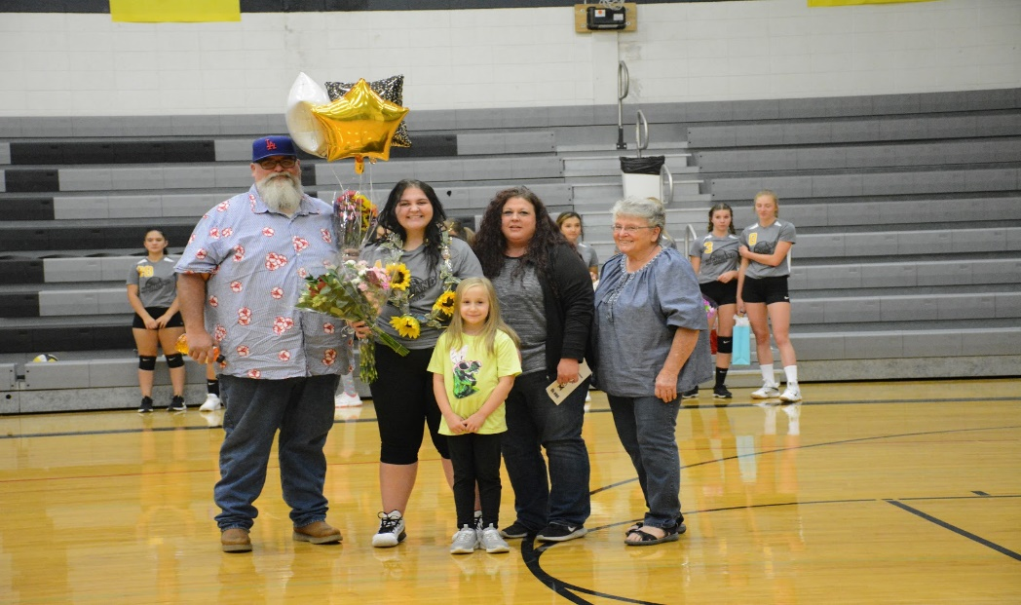
Graduating Seniors Honored at Volleyball Senior Night.

By Anna Ethridge

Samantha Bomar and Danielle Hill celebrated their senior night for high school girls’ volleyball on September 10 before beating the Timberline Spartans 3-0. Both of these girls are very hard working and determined athletes; they will be missed next year!

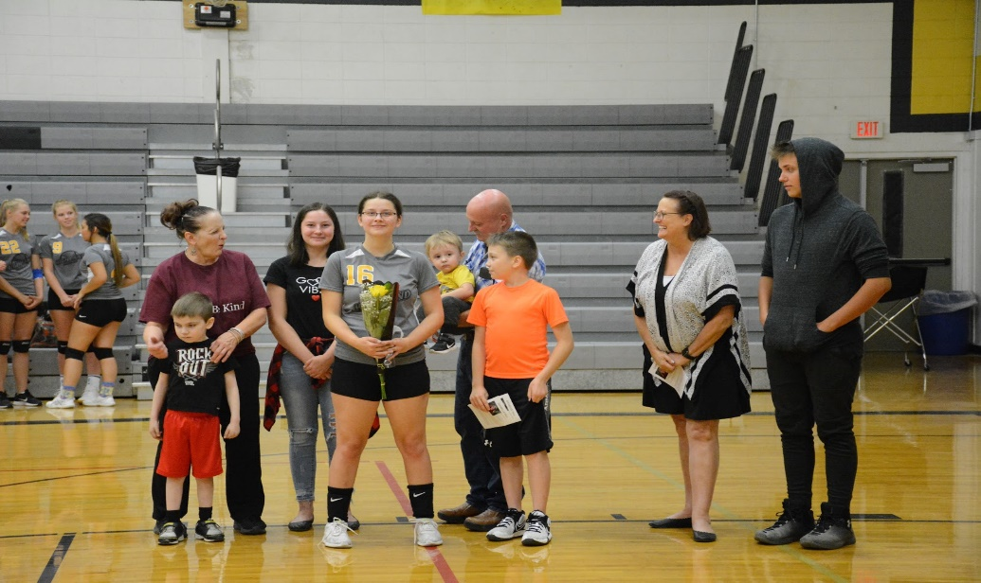
The high school volleyball team has been working diligently this season; right now they are 5-3. The Highland Huskies are in 2nd place in the 1A White Pine League, while Troy is in 1st.

Their season will soon be coming to an end. The district championships were held October 17 and that determined whether the girls headed to state or not. Look for an update next newsletter! Great job Lady Huskies!

(Top photo: Samantha Bomar and family. Bottom photo: Danielle Hill and family.)
Honor Society Welcomes New Members
By Jack Lomanto
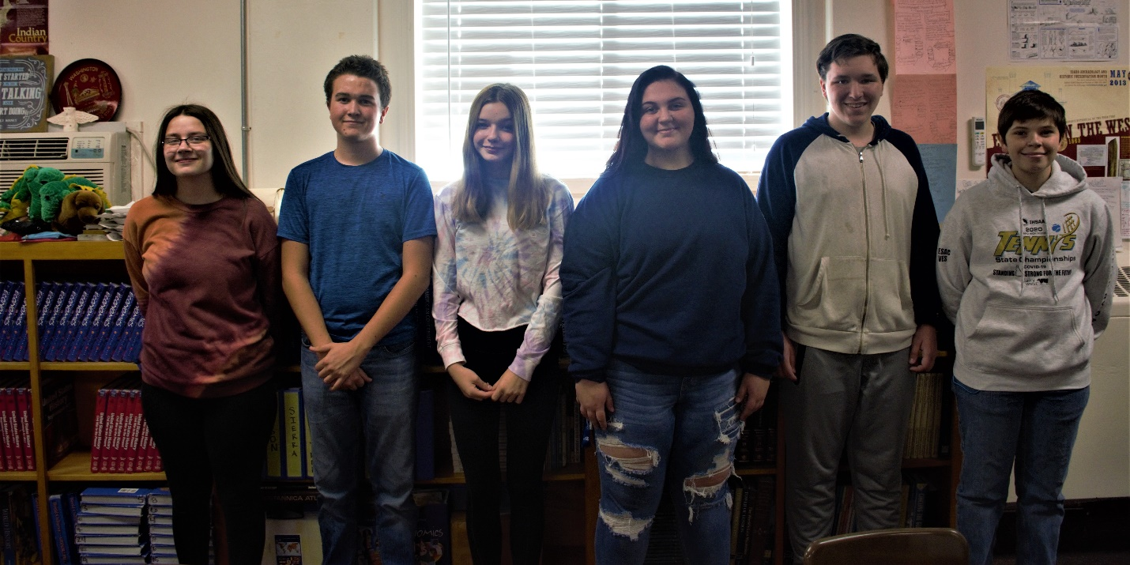
Honor Society Members: (From Left to Right) Danielle Hill, Jack Lomanto, Ellena Bennett, Samantha Bomar, Joss Reid, and Daniel Wing.

Honor Society welcomed two new members this year: Danielle Hill and Ellena Bennett. This increases the number of members to six. At the first meeting held earlier this month, the group discussed their breast cancer awareness fundraiser for the Gina Quesenberry Foundation. Members have been making pink bracelets for sale. Anyone who would like to purchase one can contact an Honor Society Member directly or drop by Mrs. Cicrich’s (Honor Society advisor) room. Bracelets may be purchased by donation. Other activities planned for this year include a small cleanup of the local cemetery on October 23 and serving Christmas dinner at the City Hall in December.

New Water Bottle Filler Station Arrives
By Danielle Hill
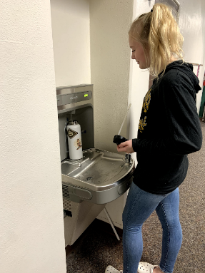
Mr. Filipponi, Shop Teacher, spent seven hours modifying and installing a new water bottle filler station for the Junior High and High School recently. The new station, which is located in the hallway near the Library, gives secondary students the ability to fill up their water bottles in the secondary wing of the building, rather than having to walk over to the elementary to get them filled.

(Left: Anna Ethridge fills her water bottle between classes.)

D and D Club Reconvenes
(Dungeons and Dragons)
By Jack Lomanto

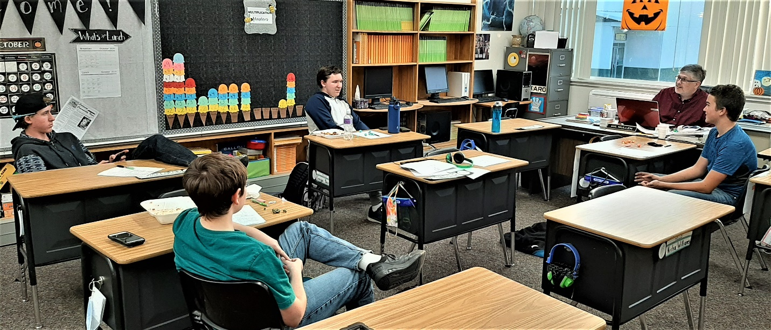
(D&D members Tristen Stang, Joss Reid, Daniel Wing and Jack Lomanto discuss strategy with their D & D advisor, Mr. Mullen).

The D& D Club began meeting in September and has waded knee-deep into Dungeons and Dragons campaign theory. The group has five members this year, including the club’s advisor, Mr. Mullen. Joss Reid and Mr. Mullen has the most experience with D&D and are willing to share everything they know.

When asked why they chose to play D&D, the answers included: The game provides a fun activity; there is the opportunity for shared storytelling; and the once a week meetings provide a chance to hang out with friends. All the players got into D&D in different ways. Some were invited by friends to play the group, while others learned about the game from relatives or online and wanted to see what D&D was all about.

*************************************************
IMPORTANT
ANNOUNCEMENT:

Culdesac School will be offering FREE BREAKFAST AND LUNCH for ALL ENROLLED CULDESAC SCHOOL DISTRICT STUDENTS.

This is a temporary waiver that went into effect September 1 and will continue through December 31.
September Student of the Month

Kindergarten with Mrs. Filon: Waylon Wilks
Waylon Wilks is the kind of person who makes sure to show respect and kindness to everyone. He will show it anytime and anywhere. While teaching class I know that I can count on Waylon to listen to directions and complete his work before he plays around. I know I can also count on Waylon to make sure to help others and keep them on task and working too. Waylon makes sure to make his own decisions and doesn’t just follow along with what everyone else is doing. He has been working really hard this month to be an outstanding student. Good work, Waylon Wilks!!

1st/2nd Grade with Mrs. Hewett: Wesley England
Wesley is a 2nd grader who is very respectful in the classroom and out of the classroom. He is always one of the first students to be ready for the class day to start. Wesley is always respectful to his teachers and fellow students. He is a very good role model for his classmates. He takes pride in his work and takes time in doing his work correctly. If he should make some mistakes, he quickly will fix his problems. If he is assigned a lesson he gets right to work to get it done on time. Wesley looks out for his fellow classmates. If he notices a classmate having trouble, he will help them out. If a classmate needs help cleaning up he will go over to help without being asked. Wesley likes to make others happy. He does not give up when presented with a hard assignment or project. He will work hard at getting it done even if it may take some extra time. Wesley has a great work attitude in class and also a great personality. He comes with a smile every day and I am so happy to have him in our class this year. Keep up the great job, Wesley!

3rd/4th Grade with Mr. Mullen: Blake Smith
Blake is a 3rd grader and takes ownership of his education by making sure his work is done well and on time. If he is absent, when he returns, he uses whatever extra time he has during the day to catch up on the things he missed while he was gone. It shows that he takes ownership, because he doesn’t hurry to get them done, he also wants to do them well. In the classroom, he and several other students began shouting encouragements whenever someone in the class was called on and answered a question correctly. This behavior has become infectious, and almost the whole class now gives encouragements when someone answers questions out loud. While Blake is not alone in this, he is a willing participant, congratulating his peers when they do well. Even when someone answers a question incorrectly, I hear shouts of “nice try,” or “that’s alright,” and “you’ll get it next time.” This is the kind of behavior I want to encourage in my classroom as it brings us all closer together and shows we can be a compassionate family who cares about everyone’s success. For these reasons, the class has helped nominate Blake for Student of the Month. Congratulations, Blake!

5th/6th Grade with Mr. Richardson: Jamison Berry
Jamison is in 5th grade and is a stellar young man who shows respect by doing everything that is asked of him. I rarely have to repeat directions for him, and he re-explains directions to those around him when they choose not to listen the first time. What impresses me the most about Jamison is how responsible he is for his schoolwork. He makes sure that every assignment is turned in on time and is done to the best of his ability. He constantly wants to know “what’s next,” so that he can work ahead to make sure he never has missing work. Keep up the great work, Jamison!

Secondary Nominations:

Wayne McComic ~ Wayne is a 7th grader and was nominated by Mrs. Cicrich.
Wayne is very respectful and polite. He never has a negative thing to say to, or about, anyone, whether it be classmates or staff. Despite being gone quite a bit at the beginning, Wayne took ownership of all of his work and made sure to get caught up quickly and efficiently. Wayne never complained about all the work he had to make up from being gone; he persevered and got it all done, while making sure that what he turned in was his best work. Great work, Wayne, and keep up all of your hard work!

Rocky Blosser ~ Rocky is a 9th grader and was nominated by Ms. Moore.
Rocky is always helpful to me and to others. He makes sure to say “please” and “thank you” after everything. He is so respectful with his words and demeanor. Rocky is always making sure that he is doing his homework correctly. He also admits when he does something wrong. He has been very understanding of how the semester has been going. There was a time where it was just him and I for class. He made the best out of the situation and made me feel like I was doing a good job as an educator. Physical Science can be a tough class to tackle. Rocky is always willing to learn new things that will help him out. He is asking for guidance and help whenever he becomes stuck on a problem.

Jimmy Lomanto ~ Jimmy is a senior and was nominated by Mr. Filipponi.
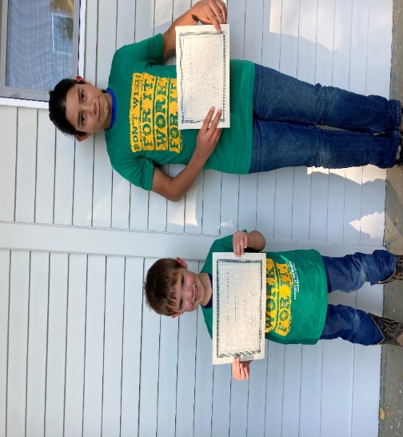
Jimmy is always ready to work on any project with a great attitude and attention to detail. Jimmy works hard on his projects and takes pride in doing a good job. He is a great role model to his classmates. Jimmy is also a rock star on the playground with the elementary students. Jimmy will continue to work on a project even when faced with roadblocks. He will find the information he needs and will ask for help when needed. Congratulations, Jimmy!

Elementary Winner: Waylon Wilks
Secondary Winner: Wayne McComic

SAVE THE DATE: The Culdesac Board of Trustees Meeting is Scheduled for Tuesday, November 17th at 7pm.
WANT TO HEAR A STORY?
Earlier this month, the Journalism class invited students from the Junior High and High School to submit their own spooky stories to share in honor of Halloween. We received quite a few wonderful entries! Each of the students who submitted their writing will receive a bag of Halloween candy. After much deliberation, we chose the following story as our winner for the month of October. It is written by Katelyn Campbell, an 8th grader. It is entitled, “The Missing Girl.” Congratulations Katelyn!
The Missing Girl
Mike: Hey Kayla!
Kayla: Oh, hey Mike.
Mike: You and your family should come to Russia with us on Monday!
Kayla: Umm…I don’t know. I’ll ask them when school is over!
Mike: Ok! Fingers crossed. Ha Ha.

NEXT DAY: (Texting)
Mike: Did you say yes?!
Kayla: Yup!
Mike: Cool! See you on Monday.
Kayla: Alright.

TEXT FROM UNKNOWN NUMBER:
Unknown: DON’T GO ON THAT TRIP!!
Kayla: Why not?! Never mind. Who are you?
Unknown: That’s not important. Just don’t go on that trip!
Kayla: Ok, whatever, freak! I don’t know you!
*BLOCKS NUMBER*

(MONDAY) *ALARM CLOCK: BEEP, BEEP, BEEP, BEEP

Kayla: *gasps* The trip!

Halloween story By: Danielle Hill
Scarlett walked along the sidewalk as usual on her way home from school. She noticed that on this particular day it was chillier and she wished she had brought a jacket. She could see her breath float away into the air, and the trees had lost all of their leaves; even the sidewalks were a bit icy. It was just a typical October day though. Only five days from Scarlett’s favorite holiday, Halloween. The one night of the year she can stay up; enjoying candy from an evening of hard work obtaining it.
Scarlett was still walking on the same sidewalk to her journey home, but home felt as if it were growing further and further away. The clouds began to darken, and lightning was striking the ground. Scarlett started to sprint down the sidewalk in an attempt to get home quicker.
Soon, Scarlett was struck by lightning. She was halted in her tracks and she was frozen in fear, her world began to spiral out of reality. She was spinning and was soon in what felt like home, but everything was off just a bit.
Scarlett was just glad to be home. She went searching for her parents, in particular her mom. She knew her dad wouldn’t be home yet from work. She walked to her parents room to find no trace of her parents. Nothing in the room felt like it was her parents. She fretfully walked towards the kitchen to see if her mom had left her a note. To Scarlett’s surprise someone was in her kitchen.
“Hi dear, how was school today?” The lady asked Scarlett in a soft tone.
“Wh-Who are you?” Scarlett asked, her voice was trembling in fear.
“Scarlett, what has gotten into you? I’m your mother! You silly girl.” The lady persisted.
“You are not my mother! Where are my parents?” Scarlett demanded.
“Go on in and lay down Scarlett, I think you are tired after a long day of school” The lady suggested.
Scarlett raced to her room and threw herself onto the bed, covering her face in the pillows and blankets. Tears streamed down her face, her face grew warmer with each tear she cried.
Soon she was asleep, and dreaming about her family, not the random lady in her house that is imposing as her mother. She dreamt of her mother and father, and even her annoying baby brother. She missed them all dearly; and she wanted to go home.
Scarlett awoke and it was the next morning.
“Scarlett, dear, please come downstairs.” an echoing voice was coming from downstairs.
Scarlett fled the stairs and made it to the kitchen. Her face dropped when her eyes met the lady that was in the kitchen. That was still not her mother.
Before Scarlett could say anything or think another thought the ladies’ soft voice broke the silence:
“It’s Halloween, lets go get your costume today.” The lady said with optimism in her voice.
“I thought it was still Tuesday?” Scarlett said, confused. Although she was still certain the lady was not her mother; she really loves Halloween and was excited.
“Can I be whatever I want to be?” Scarlett asked, even though she knew she would be breaking the boundaries.
“You can be whatever you would like, my dear!” The lady exclaimed.
It was all too good to be true, Scarlet thought. She picked out a character from her favorite show and was soon walking with a group of kids from school trick or treating for candy.
“Something weird is happening to me.” Scarlett meekly said to her peers.
“What do you mean Scar?” One of the boys inquired.
“You see, the other day, I was going home after school, and when I got home, my parents weren't my parents anymore.” Scarlett said to the group of kids.

One of the kids’ faces turned whiter than a ghost, and he stopped walking. The other kids were still walking along, but Scarlett noticed he was still behind; so she walked towards him.
“What’s wrong?” Scarlett asked the boy.
“The same thing happened to me and my parents. I can help you get back to them.” the boy offered.
“Please” Scarlett begged.
“I got my parents back by going back to where it all happened and I waited for the next storm to strike. Then you have to battle the evil pumpkin king and you are free to go home.” the boy said with enthusiasm.
“Really?! That’s all?” Scarlett was shocked.
“I've got to go!” Scarlett yelled racing down the street to get back to the sidewalk that changed her life.
She arrived at the sidewalk and watched as the raindrops fell onto the pavement. Thunder began grumbling from the skies, and soon Scarlett was in another dimension like the day her life changed.
“I see you have come to see me” A deep voice came booming from the clouds.
“Are you God?” Scarlett asked.
“NO! I am the Evil Pumpkin King! Here to make you battle for what you have lost!” The voice was ten times louder than before.
“I just want my parents back!” Scarlett said crying. The tears flooded her face and made her face hot.
“You stupid little girl! What makes you think I want to give them back to you if you are crying and acting like that?!” The Evil Pumpkin King scowled.
Scarlett sniffled and wiped her tears.
“You must find a way to come up here and defeat me.” The Evil Pumpkin King said with a smirk.
“Now how do you expect me to do that?” Scarlett said and scoffed.
“That is for me to know and you to find out.” The Evil Pumpkin King mocked.
“-Oh and your time starts now! You have an hour to do so, or your parents are toast.” The Evil Pumpkin King said ever so sly.
Scarlett began to think to herself how she could defeat the Evil Pumpkin. She wondered if the lady that was at her house was truly the pumpkin king in disguise.
She sprinted down the sidewalk, and all the way to the house.
“Mom! Mom?!” Scarlett yelled.
“Yes dear?” The lady asked in her soft tone.
“Can you sort through my candy for me to make sure it is safe?” Scarlett sneakily asked.
Scarlett planned to kill the lady because she was really the Evil Pumpkin King in disguise.
“Of course dear” The lady obliged.
Scarlett raced over to the lady and killed her.
“Scarlett sweetheart, it’s okay, wake up sweetie, it's just a dream.” a familiar voice echoed through the room, as Scarlett's eyes shot open.
“Mom! I thought I lost you forever, I didn't think I was ever going to be able to get you back! I love you so much mom!” Scarlett said with the biggest smile on her face, and tears streaming down her cheeks once again.
“I have no clue what you are talking about, it must have been some dream.” her mother said while hugging Scarlett.
As Scarletts’ mother was holding her in the warm embrace, a strange man appeared in the doorway.
“Scarlett my daughter, oh how have I missed you.” The man was not her father.
Scarlett was still trapped in the other dimension.
The End

